
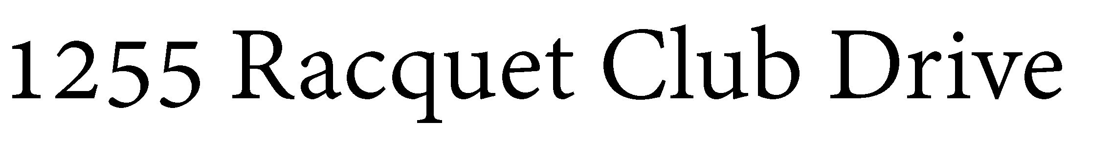

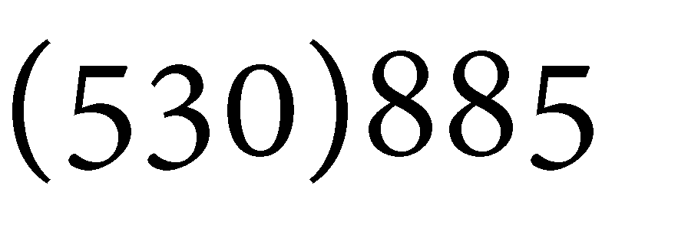



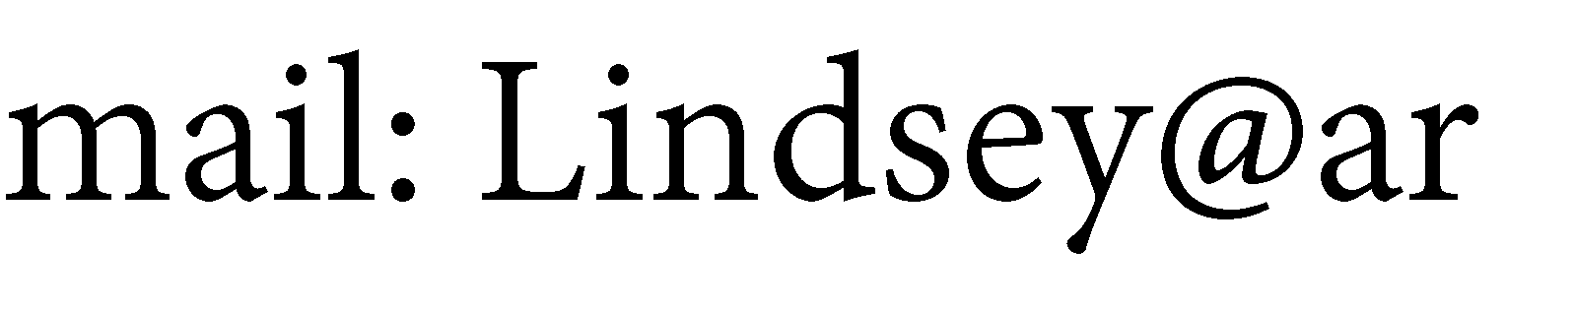














2024


Well-Fit Exercise Program

ForWho Program Director Well-Fit Program Registration Form 2024

This program is designed for anyone who is currently deal­ ing with cancer, or has been treated in the last year, and wants to regain strength, balance, and energy.

Program Goals
Our goal is help the cancer recovery process by
restoring strength, balance, energy, and confidence. Our primary focus is to condition the Muscular and Cardiovas­ cular Systems through gradual resistance and range-of­ motion exercises. We utilize the state-of-the-art exercise facilities at the Auburn Racquet & Fitness Club to intro­ duce progressive weight training, gradual cardiovascular conditioning, core and balance training.

The Well-Fit program combines the latest in exercise sci­
Lindsey has several certifica­ tions through the American Council on Exercise, including Personal Training, Senior Fit­ ness Specialist, Fitness Nutri­ tion Specialist, Orthopedic Exercise Specialist, Biomechan­
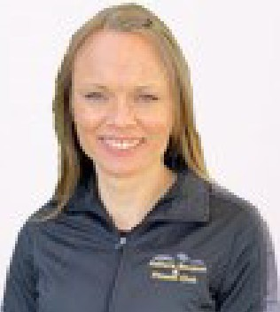
ics Specialist, Pilates Reformer Instructor, Cancer-Exercise Specialist in progress. Lindsey has earned a Bachelor's Degree, Magna Cum Laude, in Sports and Health Sciences with a concentration on Exercise Science.

The Cancer Well-Fit Exercise Program is sponsored by the Auburn Racquet & Fitness Club.
Name:

Phone:

Email:--------------------

Schedule
Mondays/ Thursdays at 11 AM
Choose a Session:

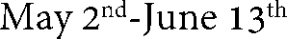
□

□

ence with a supportive and motivating environment to assist the recovery process.

Cost
The Well-Fit Exercise Program is sponsored by the Auburn Racquet & Fitness Club and is offered free to anyone cur­ rently dealing with cancer.


Where

The Auburn Racquet & Fitness Club 1255 Racquet Club Drive
Auburn, CA 95603
- August 12th-October 3rd
- October th-November 28th

